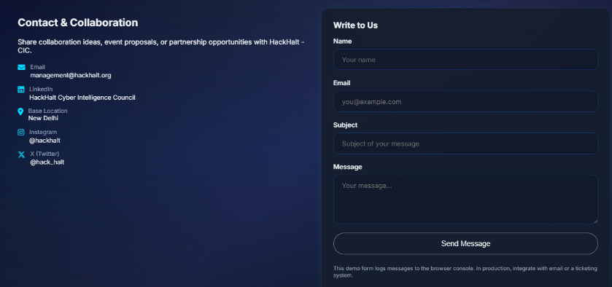
Remove this is demo form written part from form
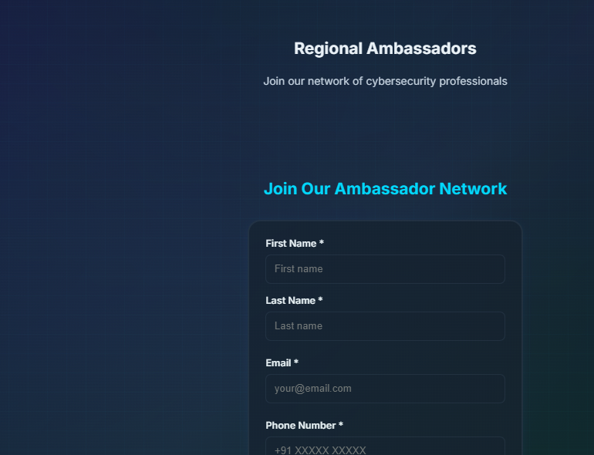
Adjust the size of regional ambassadors form
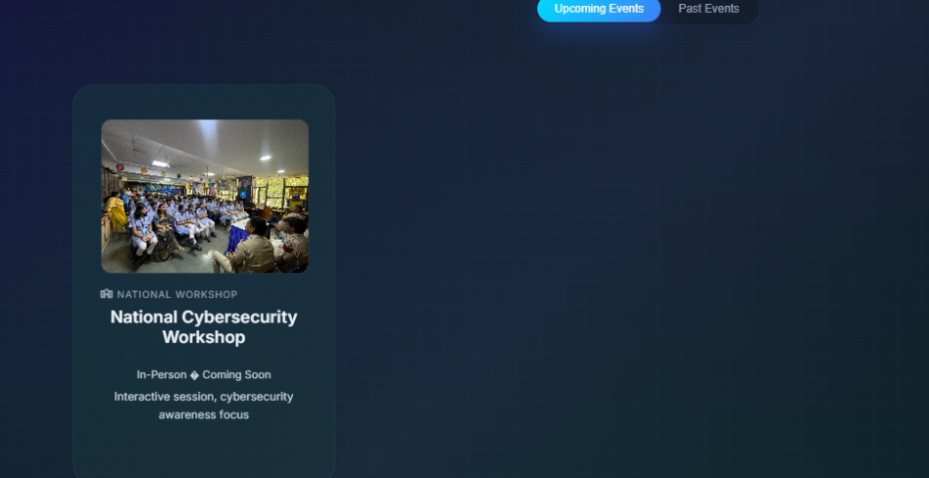
Remove this and add Security in Ai Summit 2026

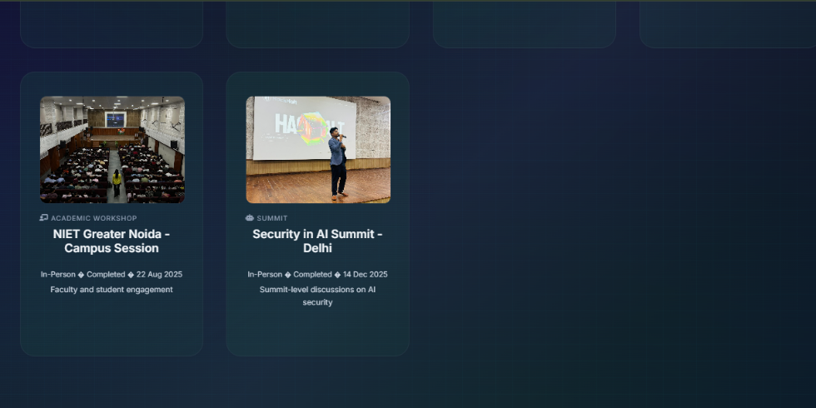
Change the name of security in ai summit delhi replace with Pre-meetup event security in summit 2026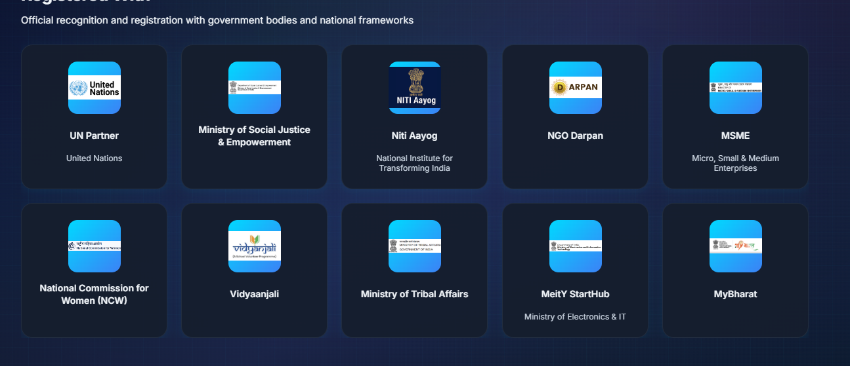

Remove niti arayog and add Registered With BIS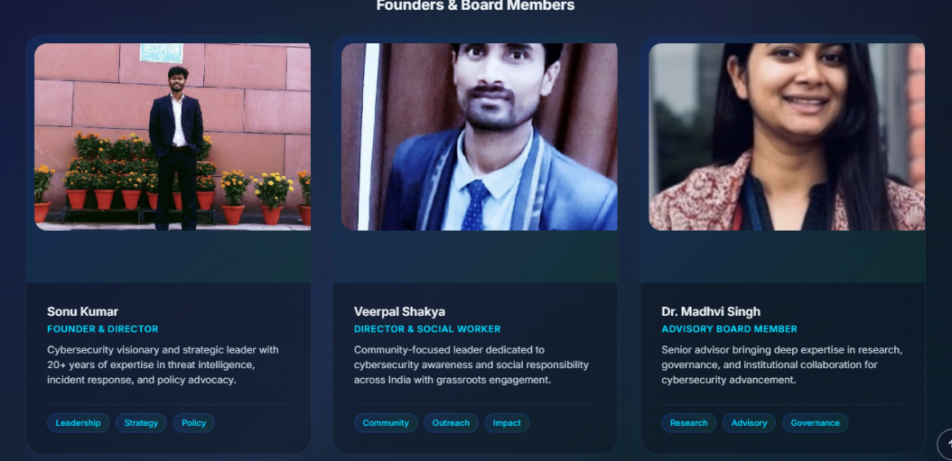

Change the frame and add our Honorary Advisor Dr Deepak (D3)Forensics
Photo sent into group

